

The Wine WebGUI App

Students:
Alberto De Armas
Tarun Singh Thakur
Himanshu Parihar

Overview
Wine is being consumed around the world from centuries ago. Different countries have different varieties of wines and winemaking procedures. Due to such a large variety, people often face problems in selecting one or trying a new kind of wine.
We are trying to build a WebGUI using wine.csv dataset. Our WebGUI app will try to redefine the way people look for wines!
We were able to find a large dataset with different types of wine around the world. The attributes allows us to determine the taste, type, brand, country, and score. Our idea is to create a WebGUI interface that allows the customer to pick a wine of their preference according to the characteristics previously picked by the client. We plan to achieve our goals using the skills learned of D3 and Javascript taught in class.

Data Specifications
The dataset is in a CSV file and the attributes are the following:
- Item ID
- Country
- Description
- Points
- Price
- Province
- Title
- Variety
- Winery
The file contains 129972 rows and it is 46643 KB

Goals
- Make a friendly WebGUI app that allow customers to find a wine according to their needs.
- Provide visualizations that help the customer investigate through our dataset of wines.

Tasks
- We would be using country attribute to visualize various countries.
- We would be using points and variety attribute to visualize the relationship between them.

Proposed Visualizations and Interactions

Visualization:
- We will create a collapsible tree, shown below, which will provide us the list of wines available in various countries.
- Wine would be alone available for the selection.
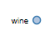
b. Upon selection of wine, various countries would be listed.
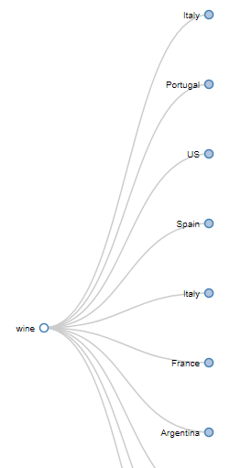

c. When particular country is selected then the varieties available in that country will be displayed.
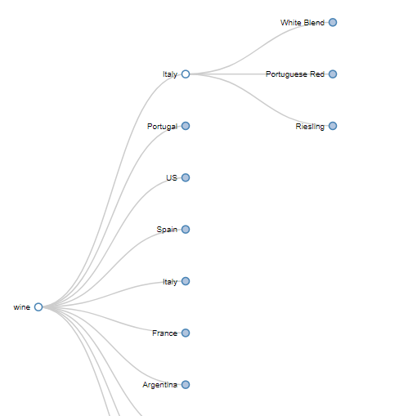

2. We will create a geo map which details about the countries where best wines are available.
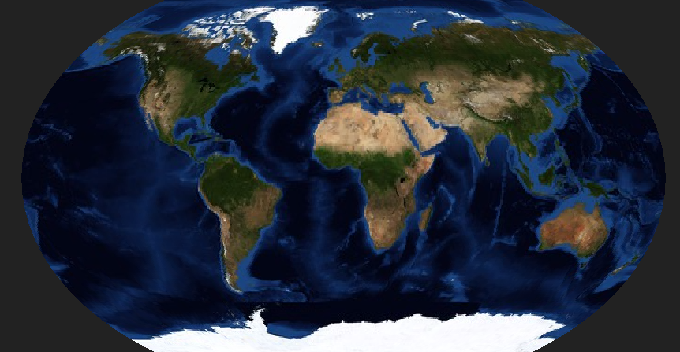

Interactive Visualization:
- One of the interactive visualization is when we select the country then the corresponding list of wine varieties would be displayed.
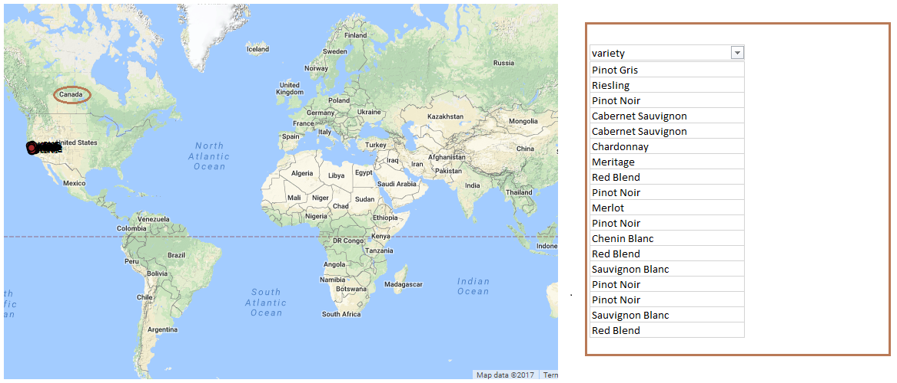

2. By selecting the wine, we would like to display the points associated with it. We would be trying different visualization based on D3 but for simplicity, we have provided the below screenshot.

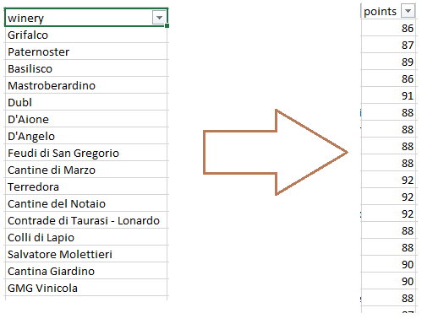

Constraints

Time
We have a little less than 3 weeks to finish this project.

Javascript and D3 lack of knowledge
In our group, there is no student with previous experience in D3 or Javascript. We will strive for the best.

References :
1)https://www.kaggle.com/zynicide/wine-reviews/data
We found wine dataset on kaggle. It contains interesting information on type of wine with points and availability in the countries. We can use this data set for creating some interesting visualization.
We spent some time in understanding the relationship between the countries, variety of wines and the points associated with it.
2) https://bl.ocks.org/mbostock
Our data set contains a lot of countries. While looking for ideas for visualization, We found this “ The global center mass of education” by Denes Csala.This visualization talks about “global shift of global center of mass” of top 500 universities towards east. It represents top 500 universities around the globe. We can take reference and create an interactive visualization which will represent the country and wine detail in that respective country.
3) https://bl.ocks.org/mbostock/4339083
This is an example we found on Mike Bostock’s website. It is a very cool and interactive way to visualize data with many sub categories. At the start, we have one parent node which can be expanded into its child node by clicking on it. The child nodes can be further divided into their child nodes. And same process goes on collapsing the nodes.
We are taking reference from this example to represent top 5 countries in terms of variety of wine available in the country.

Exploration
We would be exploring more better ways to represent the data and will try to incorporate more visualizations and interactions. The base idea is to create an app which would guide the consumers to pick the best wines available in various countries based on the points awarded to it. We would be developing the visualization with better interactions and effects.

